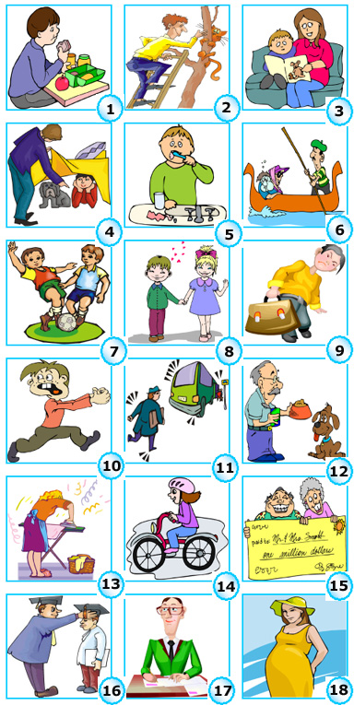
Past Perfect Simple
AFFIRMATIVE
Subject+ had+ past participle
NEGATIVE
Subject+ hadn’t+ past participle
INTERROGATIVE
Had +subject+ past participle

Past Perfect Continuous
AFFIRMATIVE
Subject+ had been+ verb+ ing
NEGATIVE
Subject+ hadn’t been+
verb+ ing
INTERROGATIVE
Had +subject+ been+
verb+ ing

FORM

USE OF THE TENSE
Past Perfect Simple
For an action completed before a certain moment in the past.
Example: I had already found my pen when my mum came home.

Past Perfect Continuous
For an action which began before a moment in the past, and was still going on at the moment.
Example: We went out because the sun had been shining for hours.

▪ ALREADY is used in affirmative sentences before the past part.
I had already rung Mary.
▪ JUST is used before the past participle to mean that something had happened recently
I had just left my office.
▪ NEVER is used before the past
participle to mean you had not experienced something in your life until a certain time in the past:
I had never eaten caviar until I went to Russia last year.

ALREADY – JUST – NEVER –WHEN - BY THE TIME- AFTER- BEFORE – UNTIL – FOR - SINCE

▪ NEVER is used before the past
participle to mean you had not experienced something in your life until a certain time in the past:
I had never eaten caviar until I went to Russia last year.
▪ WHEN is used with the past perfect to show that something is completely finished:
When I had finished the exercises I went out.

▪ BY THE TIME is used with the past simple to state a point in the past before which something else had happened:
By the time I got home the child had already gone to bed.
FOR AND SINCE are used to say that something began before a moment in the past and still continues:
She had been crying for 3 hours when I called her.

Complete the sentences using a suitable verb from the list in the Past Perfect simple or continuous:

BRUSH NOT CLIMB FEED SCORE HIDE FIND
DO BECOME LEAVE TELL SEE WIN HAVE
RIDE NOT FINISH GRADUATE PUT WRITE

- By the time the bell rang, Mark ___________ his lunch at the canteen.
- Bob’s cat ________________ up a tree before the day it saw the neighbour’s new bulldog.
- Jim’s mother __________ just _________ him a beautiful tale when somebody rang the door bell.
- Peter and his dog ________________ for 30 minutes under the table by the time Peter’s father started looking for them.
- Dave _________ already ____________ his teeth before his mother told him to go to bed.
- They ___________ never __________ a ride in a gondola until they went to Venice last year.
- By the time the match finished, the boys _____________ three goals.
- They _________ already ________ best friends before they started going to primary school.
- Bob couldn’t lift the bag as he __________ a lot of books in it.
- Ted started to run after he _______________ the dangerous dog.
- The bus ______ already ______ by the time he arrived at the bus stop.
- Henry ______________ the dog for one hour when he heard a strange noise upstairs.
- Lara ___________ the ironing by the time her husband returned home.
- Tina _____________ her new bike only twice before someone stole it.
- They went on a trip round the world as they ______________ a lot of money one year before.
- Alan ____________as a doctor before his parents moved to London.
- He _______ just _______ his girlfriend a letter when she phoned him to tell him she was in town.
- Lisa got pregnant two months after she_______________ a good job. 

▪ AFTER , BEFORE and UNTIL are used with the past simple and past perfect with no difference of meaning:
After he finished the report he went home or After he had finished the report he went home.
He didn’t leave until he spoke to his boss or He didn’t leave until he had spoken to his boss.

